**SQL-3**

**Date:**

**AIM:** To create tables FACULTY and COURSES and execute the SQL commands.

**QUERY:**

**Create tables FACULTY and COURSES, write and execute the SQL queries for the given questions and observe the outputs.**

**Table: FACULTY**

|  |  |  |  |  |
| --- | --- | --- | --- | --- |
| **F_ID** | **Fname** | **Lname** | **Hire_date** | **Salary** |
| 102 | Amit | Mishra | 12/10/98 | 12000 |
| 103 | Nitin | Vyas | 24/12/94 | 8000 |
| 104 | Rakshit | Soni | 18/05/96 | 14000 |
| 105 | Rashmi | Malhotra | 11/09/97 | 11000 |
| 106 | Sulekha | Srivastava | 05/06/99 | 10000 |

**Table: COURSES**

|  |  |  |  |
| --- | --- | --- | --- |
| **C_ID** | **F_ID** | **Cname** | **Fees** |
| C21 | 102 | Grid Computing | 40000 |
| C22 | 106 | System Design | 16000 |
| C23 | 104 | Computer Security | 8000 |
| C24 | 106 | Human Biology | 15000 |
| C25 | 102 | Computer Network | 20000 |
| C26 | 105 | Visual Basic | 6000 |

**PROCEDURE:**

**1.** Open mysql software.

**2.** Enter the password.

**3.** Enter the following commands in the mysql prompt, mysql >

**4.** Create Database

**5.** Create table FACULTY(F_ID integer, Fname char(25), Lname char(25), Hire_Date date, Salary integer );

**6.**  Insert into FACULTY values(102,'Amit','Mishra',12/10/98,12000);

(Repeat this command with different values to insert all the records in the table FACULTY)

**7.** Create table COURSES(C_ID char(5), F_ID integer, Cname char(25), Fees integer);

**8.** Insert into COURSES values('C21',102,'Grid Computing', 40000);

(Repeat this command with different values to insert all the records in the table COURSES)

**SQL Commands:**

1. **To display details of those faculties whose salary is greater than 12000.**

1. **To display the details of courses whose fees is in the range of 15000 to 50000(both values are included)**

**3. To increase the fees of all courses by 500 of the course whose Cnmae starts with**

**“Computer”.**

1. **To display details of those courses which are taught by 'Sulekha' in desending order of courses.**

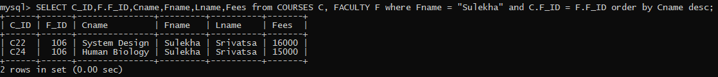

1. **To display the number of make F_ID in the COURSES table.**

1. **To display the name of the faculty who gets maximum salary.**

1. **To display the faculty name with the name of the courses taught by them.**

**RESULT:**

The SQL commands for the given queries are executed successfully and the outputs are observed.